

Darshan University

A Project Report on

**“R.T.O. Learning License Practise Test”**

Under the subject

**Software Engineering (2101CS503)**

B. Tech, Semester – VI

Computer Science & Engineering Department

|  |  |
| --- | --- |
| Submitted By | |
| Student Name: Khunt Karan K. | Enrollment No.: 21010101108 |
| Academic Year  (2023-2024) | |
| Internal Guide  Prof. XYZ  Darshan University | Dean-DIET  Dr. Gopi Sanghani  Darshan University |

|  |  |
| --- | --- |
|  | **Computer Science & Engineering Department**  **Darshan University** |

**DECLARATION**

We hereby declare that the SRS, submitted along with the **Software Engineering** **(2101CS503)** for entitled **“Project Title”** submitted in partial fulfillment for the Semester-5 of **Bachelor Technology (B. Tech)** in **Computer Science and Engineering (CSE)** Departmentto Darshan University, Rajkot, is a record of the work carried out at **Darshan University, Rajkot** under the supervision of (**Guide name)** and that no part of any of report has been directly copied from any students’ reports, without providing due reference.

(Student name)

Student’s Signature

Date: __________

|  |  |
| --- | --- |
|  | **Computer Science & Engineering Department**  **Darshan University** |

**CERTIFICATE**

This is to certify that the SRS on **“Project Title” has** been satisfactorily prepared by **Student name** (**Enrollment**) under my guidance in the fulfillment of the course **Software Engineering (2101CS503)** work during the academic year 2023-2024.

|  |  |  |
| --- | --- | --- |
| Internal Guide  Prof., Guide Name  Darshan University |  | Dean-DIET  Dr. Gopi Sanghani  Darshan University |

**Acknowledgement**

I wish to express my sincere gratitude to my project guide Prof. **Guide name** and all the faculty members for helping me through my project by giving me the necessary suggestions and advices along with their valuable co- ordination in completing this work.

I also thank my parents, friends and all the members of the family for their precious support and encouragement which they had provided in completion of my work. In addition to that, I would also like to mention the Darshan University personals who gave me the permission to use and experience the valuable resources required for the project from the University premises.

Thus, in conclusion to the above said, I once again thank the faculties and members of **Darshan University** for their valuable support in completion of the project.

Thanking You

**Student Name**

**Abstract**

R.T.O. Driving Test System is use for before R.T.O. exam People are learn MCQ and give Exam like Real exam.

This Project has Many information Which are generally People are not Know like license Procedure, Driving Law R.T.O Code and office's address, Fitness of vehicle, PUC information etc.

It has also a facility where people are use application in their language.

**Table of Contents**

List of Figures I

List of Tables II

1 Introduction 1

1.1 Procudet Perspective 1

1.2 Product Features 1

1.3 Functional Requirement 2

1.4 Non-Functional Requirement 3

1.4.1 Usability 3

1.4.2 Accuracy 3

1.4.3 Availability 3

1.4.4 Maintainability 3

2 Design and Implementation Constraints 4

2.1 Use-case diagram 4

2.2 Activity Diagram 5

2.3 Swimlane Diagram 6

2.4 Sequence Diagram for check R.T.O. office detail 7

2.5 State Diagram 8

2.6 Class Diagram 9

2.7 Data Flow Diagram 10

2.7.1 Context Diagram (level-0) 10

2.7.2 DFD Level-1 11

2.7.3 DFD Level-2 12

3 External interface requirement (Screens) 13

3.1 Screen-1 : Exam 13

3.2 Screen-2 Driving License Procedure 14

3.3 Screen-3 RTO Code & office 15

3.4 Screen-3 Home Page 16

3.5 Screen-5 Practice 17

3.6 Screen-6 FAQ 18

3.7 Screen-7 Driving Laws 19

3.8 Screen-8 Question Bank 20

4 Database Design 21

4.1 List Of Tables 21

5 Story & Scenario 23

5.1 Story-1: Read RTO Office Detail 23

5.1.1 Scenario# S1.1 23

5.1.2 Scenario# S1.2 23

5.1.3 Scenario# S1.3 23

5.2 Story-2: Demo Exam 24

5.2.1 Scenario# S2.1 24

5.2.2 Scenario# S2.2 24

5.2.3 Scenario# S2.3 24

5.3 Story-3: Select State and Language 25

5.3.1 Scenario# S3.1 25

5.3.2 Scenario# S3.2 25

5.3.3 Scenario# S3.3 25

5.4 Story-4: Add Question 26

5.5 Story-5: Statistics 26

5.6 Story-6: License Procedure 26

5.7 Story-7: Driving Laws 26

5.8 Story-8: Question Bank 27

5.9 Story-9: Practice Test 27

5.10 Story-10: FAQ 27

6 Test Cases 28

# List of Figures

Figure 2.1‑1 Use case diagram for RTO learning licence practice test 4

Figure 2.2‑1 Activity diagram for user 5

Figure 2.3‑1 Swim lane Diagram for User 6

Figure 2.4‑1 sequence Diagram for User 7

Figure 2.5‑1 State diagram for Exam 8

Figure 2.6‑1 Class Diagram for User 9

Figure 2.7‑1 Data Flow Diagram level-0 10

Figure 2.7‑2 DFD level-1 for user 11

Figure 2.7‑3 DFD level-2 for RTO code & office 12

*Figure 3.1‑*1  *Screen-1: Registration Form* 13

*Figure 3.2‑*1  *Screen-2:* Driving License Procedure 14

*Figure 3.3‑*1  *Screen-3:* RTO Code & office 15

*Figure 3.4‑*1  *Screen-4:* Home Page 16

*Figure 3.5‑*1  *Screen-5:* Practice 17

*Figure 3.6‑*1  *Screen-6:*  FAQ 18

*Figure 3.7‑*1  *Screen-7:* Driving Laws 19

*Figure 3.8‑*1  *Screen-8:* Question Bank 20

# List of Tables

Table 3.1‑1 Screen element of Exam 13

Table 3.2‑1 Screen element of Driving License Procedure 14

Table 3.3‑1 Screen element of RTO Code & office 15

Table 3.4‑1 Screen element of Home Page 16

Table 3.5‑1 Screen element of Practice 17

Table 3.6‑1 Screen element of FAQ 18

Table 3.7‑1 Screen element of Driving Laws 19

Table 3.8‑1 Screen element of Question Bank 20

Table 4.1‑1 Table: Question 21

Table 4.1‑2 Table: Licence Process 21

Table 4.1‑3 Table: Driving Law 21

Table 4.1‑4 Table: RTO Office 22

Ta*b*le 4.1‑5 Statistic 22

Ta*b*le 4.1‑6 Admin 22

Ta*b*le 4.1‑7 User 22

# Introduction

## Procudet Perspective

In this Project learn and Practice MCQ with category like TRAFFIC SIGNS BOOKMARKS etc.

It has all Process Information like How to do apply for new Driving license How to Renewal of Driving Licence.

## Product Features

* People are use application in their language
* User are give exam like same as R.T.O exam.
* People learn R.T.O MCQ of their State
* People are learn MCQ with Category.
* application has Bookmark features.
* User find RTO Code and RTO office address
* User are visit their state RTO web site.
* people are check all RTO Procedure like New DL, PUC, Renewal of DL their steps

## Functional Requirement

* **Question Bank:** user are all question read.
* **Practice:** user are Practice for question answer.
* **Exam:** user give exam like R.T. O. real Exam
* **License Procedure:** Find the complete Process on how to apply for License.
* **Driving Law:** ACCESS a complete list of various driving laws and their Penalties
* **RTO Code & office:** You cam search for RTO Codes across Various states and cities of India
* **Statistics:** Driving Licence, vehicle Population, Road Accidents about information.
* **FAQ:** Some Impotent Document For Driving Vehicle
* **Language selection**: user are select their State Language.

## Non-Functional Requirement

### Usability

* The UI should be easy or comfortable for use for everyone.
* People can select their language.

### Accuracy

* All question and answer should be Connect.
* All RTO Office information are correct and consistency.

### Availability

* Internet is require for using the application.

### Maintainability

* The software should easily maintain and should easily add new features and make Changes.
* The Software should be updated as needed. to fix bugs and improve performance.

# Design and Implementation Constraints

## Use-case diagram

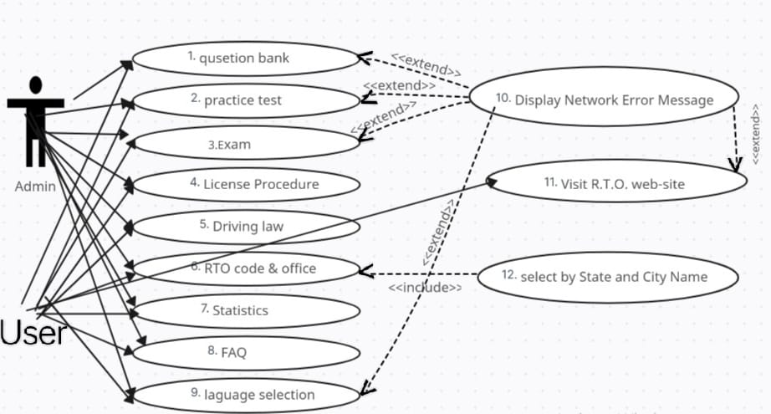

Figure 2.1‑1 Use case diagram for RTO learning licence practice test

## Activity Diagram

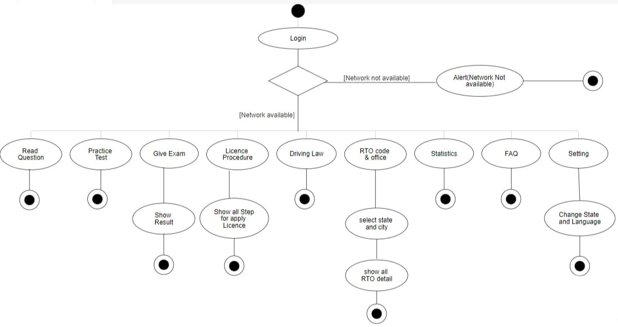

Figure 2.2‑1 Activity diagram for user

## Swimlane Diagram

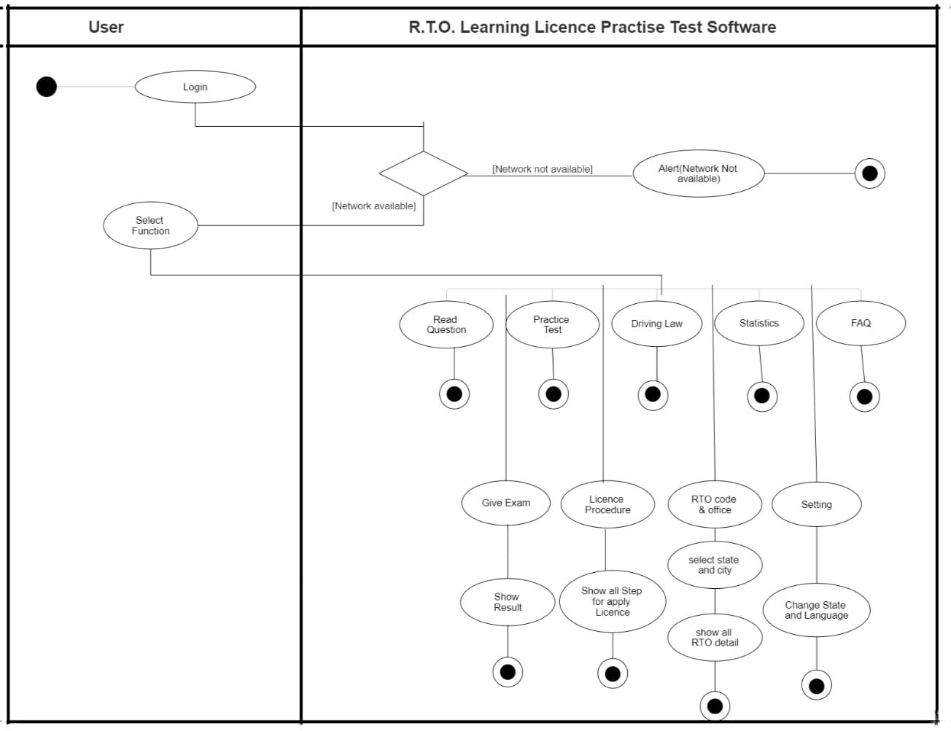

Figure 2.3‑1 Swim lane Diagram for User

## Sequence Diagram for check R.T.O. office detail

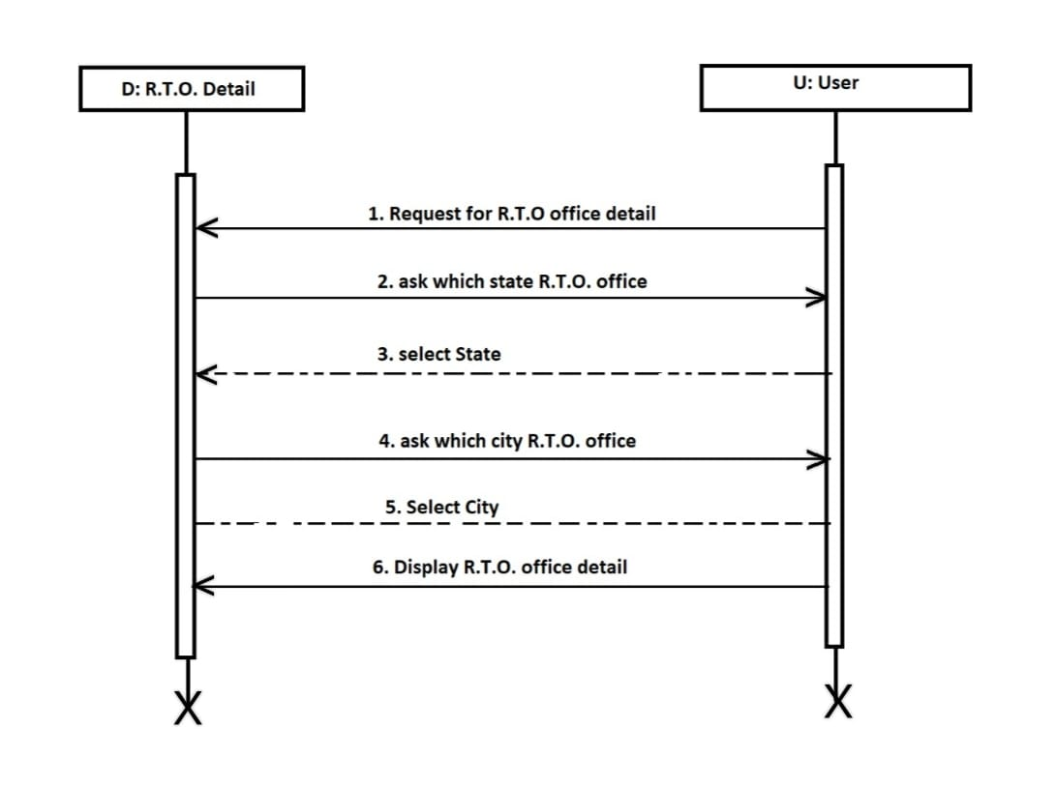

Figure 2.4‑1 sequence Diagram for User

## State Diagram

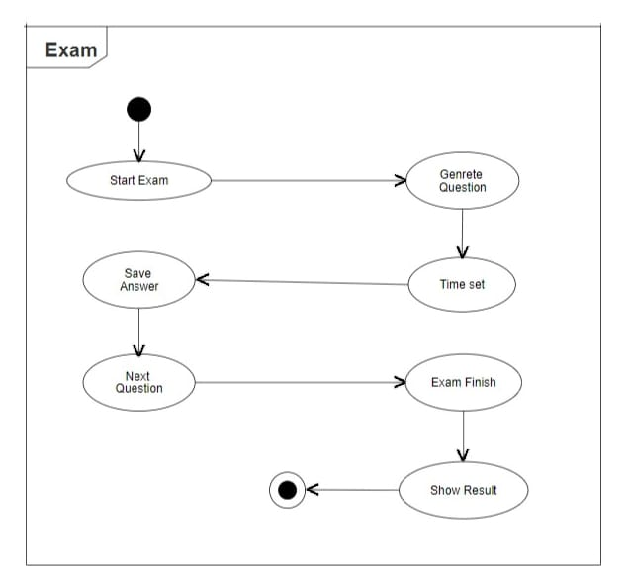

Figure 2.5‑1 State diagram for Exam

## Class Diagram

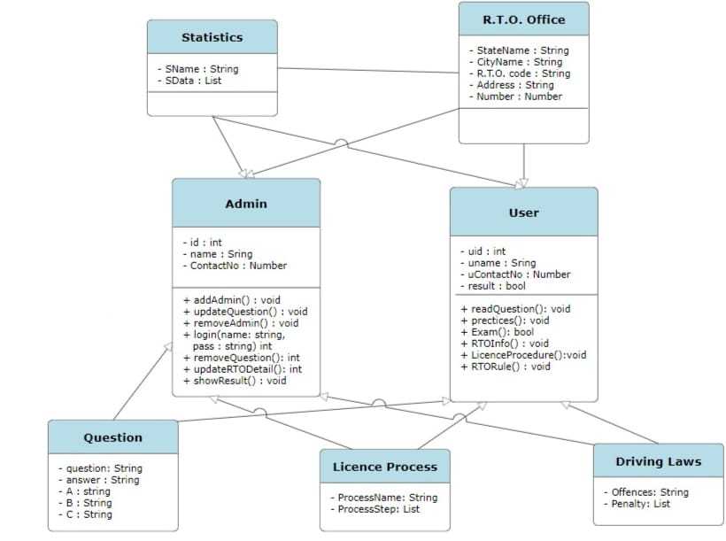

Figure 2.6‑1 Class Diagram for User

## Data Flow Diagram

### Context Diagram (level-0)

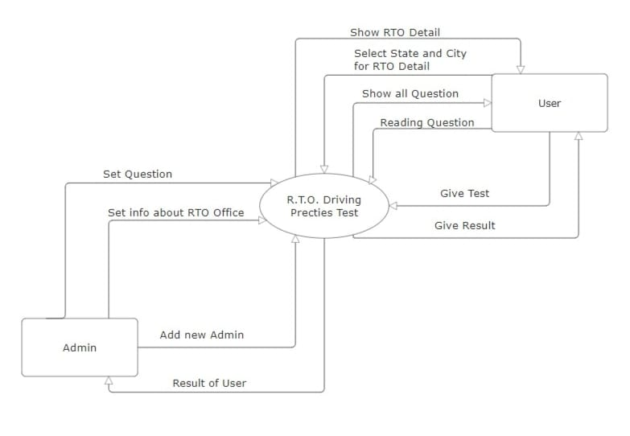

Figure 2.7‑1 Data Flow Diagram level-0

### DFD Level-1

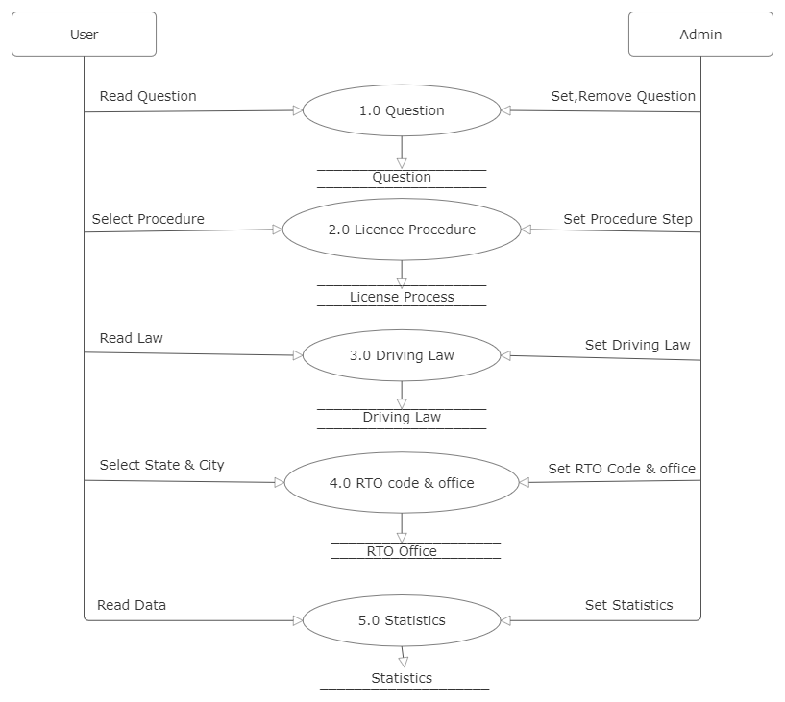

Figure 2.7‑2 DFD level-1 for user

### DFD Level-2

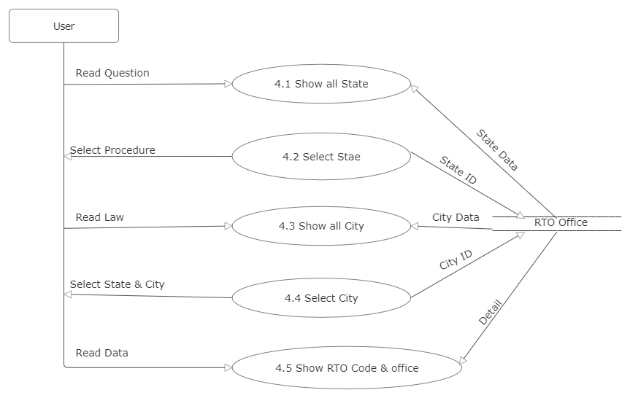

Figure 2.7‑3 DFD level-2 for RTO code & office

# External interface requirement (Screens)

## Screen-1 : Exam

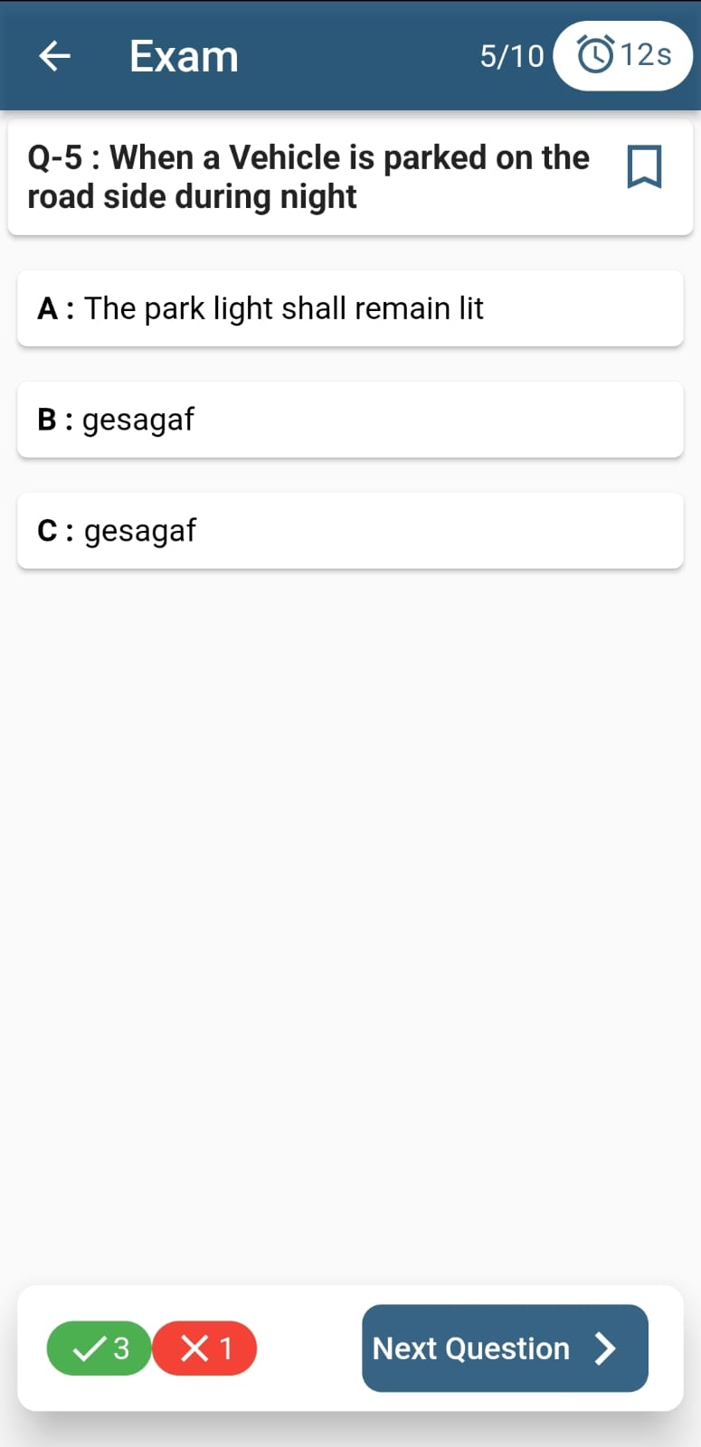

*Figure 3.1‑1* *Screen-1: Registration Form*

**Purpose:** This Screen in user give exam an after exam also check their result. This is only for Practices Exam.

Table 3.1‑1 Screen element of Exam

|  |  |  |  |  |  |
| --- | --- | --- | --- | --- | --- |
| **Sr.** | **Screen Element** | **Input Type** | **O/M** | **1/N** | **Description** |
| **1** | Back Arrow | Button |  |  | You just leave the Exam |
| **2** | Question No. | Textbox | M | 1 | Show question No. |
| **3** | Timer | Textbox | M | 1 | How man sec in choose any one option |
| **4** | Question | Textbox | M | 1 | Show question |
| **5** | Option | Button | M | N | Three option for question and one is write and other wrong |
| **6** | True,False | Textbox | O | 1 | Show how many question true, false |
| **7** | Next Question | Button |  |  | When choose to option and time is not finish then switch next question |

## Screen-2 Driving License Procedure

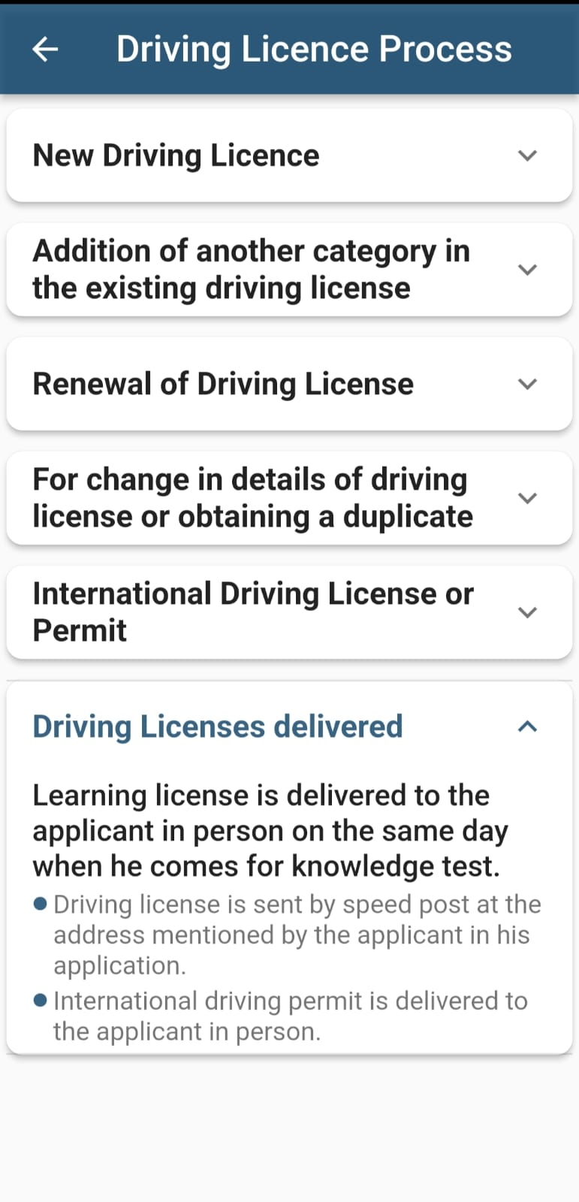

*Figure 3.2‑1* *Screen-2:* Driving License Procedure

**Purpose:** This module in user are read all the license procedure and which procedure user want to read all step then click on the procedure name.

Table 3.2‑1 Screen element of Driving License Procedure

|  |  |  |  |  |  |
| --- | --- | --- | --- | --- | --- |
| **Sr.** | **Screen Element** | **Input Type** | **O/M** | **1/N** | **Description** |
| **1** | Back Arrow | Button |  |  | Back from this page |
| **2** | Procedure Name | Dropdown | O | N | All license related procedure show in the page |

## Screen-3 RTO Code & office

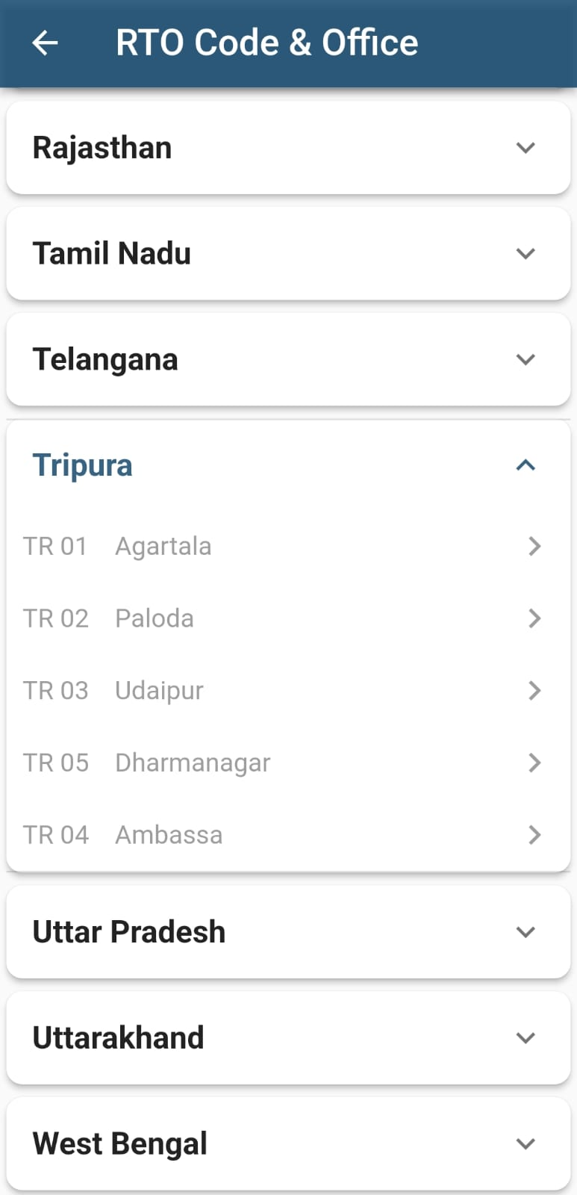

*Figure 3.3‑1* *Screen-3:* RTO Code & office

**Purpose:** This module use for check RTO office details and RTO code. First of all user select the state and after select their state city and show that city RTO office detail

Table 3.3‑1 Screen element of RTO Code & office

|  |  |  |  |  |  |
| --- | --- | --- | --- | --- | --- |
| **Sr.** | **Screen Element** | **Input Type** | **O/M** | **1/N** | **Description** |
| **1** | Back Arrow | Button |  |  | Back from this page |
| **2** | State Name | Dropdown | O | N | Show all state name which state user select those city are display and which city select those RTO office detail show |

## Screen-3 Home Page

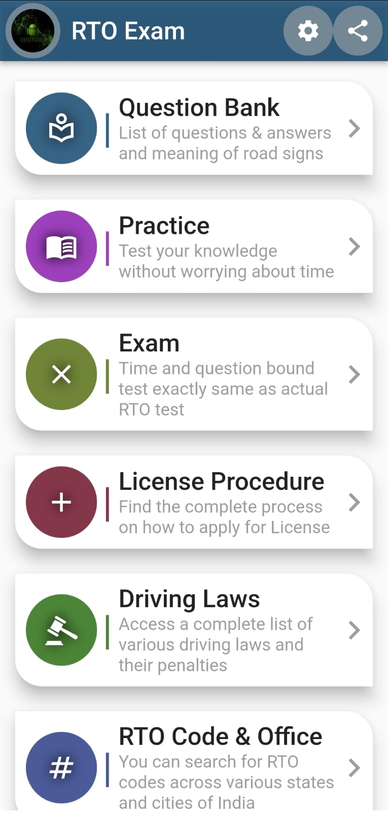

*Figure 3.4‑1* *Screen-4:* Home Page

**Purpose:** This is a use for choose different functionality in this app it is a home screen of this app.

Table 3.4‑1 Screen element of Home Page

|  |  |  |  |  |  |
| --- | --- | --- | --- | --- | --- |
| **Sr.** | **Screen Element** | **Input Type** | **O/M** | **1/N** | **Description** |
| **1** | Setting | Button |  |  | On-click to redirect on setting page and you change to state and language |
| **2** | Share | Button |  |  | On-click to share this app link via, whatshapp,blutooth,etc. |
| **3** | Menu | Button |  |  | On-click to redirect to those care page and use those functionality |

## Screen-5 Practice

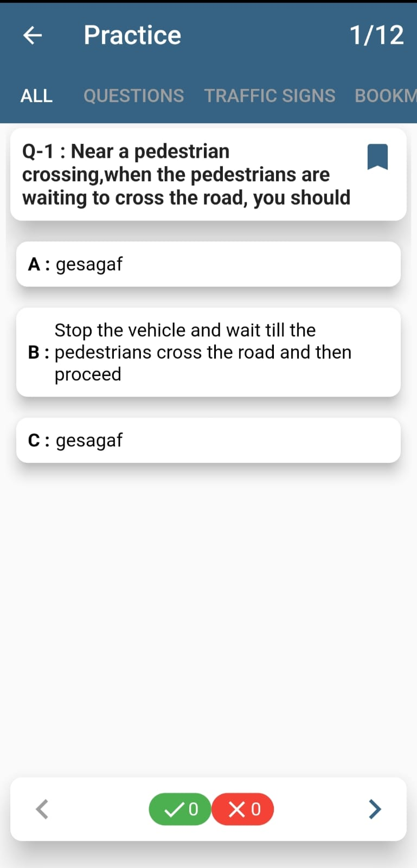

*Figure 3.5‑1* *Screen-5:* Practice

**Purpose:** it is a practice of question answer this is not a exam but this is practice test in the test you choose one option then show answer at a time

Table 3.5‑1 Screen element of Practice

|  |  |  |  |  |  |
| --- | --- | --- | --- | --- | --- |
| **Sr.** | **Screen Element** | **Input Type** | **O/M** | **1/N** | **Description** |
| **1** | Back Arrow | Button |  |  | Back from this page |
| **2** | Question Type | Button |  |  | Which type you want to read question and classification of question |
| **3** | Question | Textbox |  |  | This is Question |
| **4** | Option | Button | M | 1 | You are select any one question for answer |
| **5** | Result | Textbox |  |  | Show result |

## Screen-6 FAQ

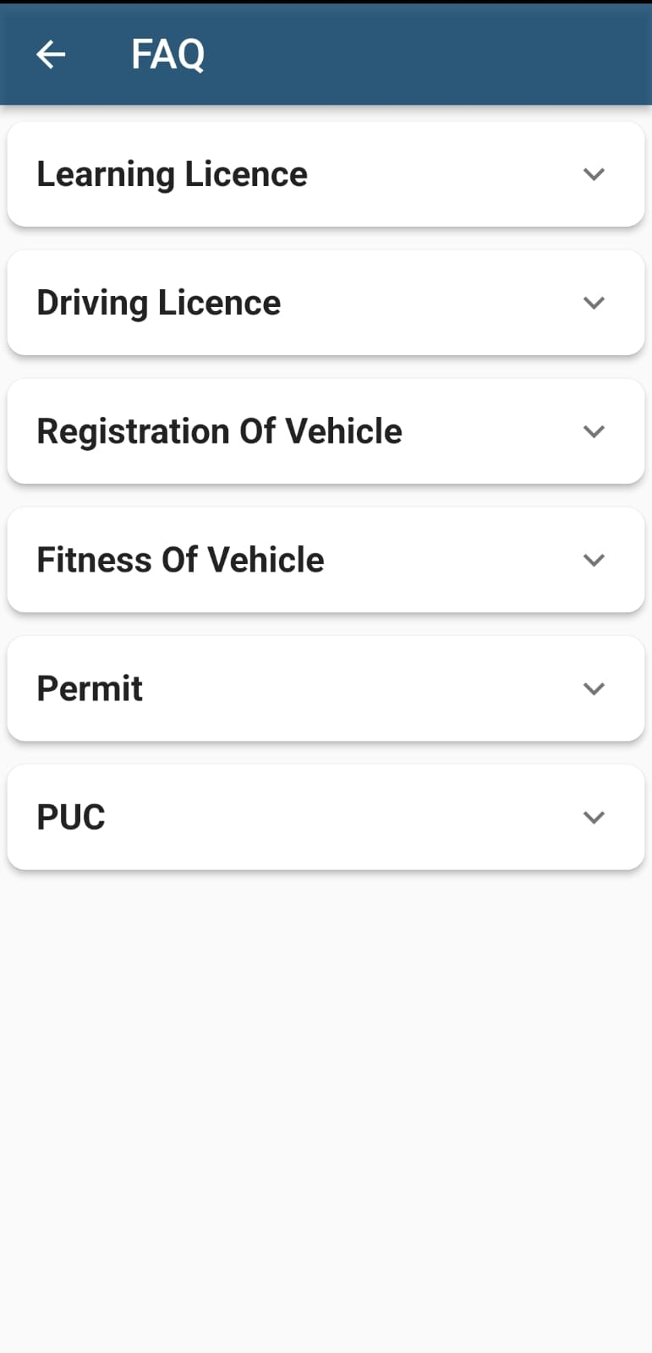

*Figure 3.6‑1* *Screen-6:*  FAQ

**Purpose:** this screen include a procedure of some document of the vehicle. You choose any one for more detail.

Table 3.6‑1 Screen element of FAQ

|  |  |  |  |  |  |
| --- | --- | --- | --- | --- | --- |
| **Sr.** | **Screen Element** | **Input Type** | **O/M** | **1/N** | **Description** |
| **1** | Back Arrow | Button |  |  | Back from this page |
| **2** | FAQ Name | Dropdown | O | N | That is different process information which process read want to you those process on click then show whole information |

## Screen-7 Driving Laws

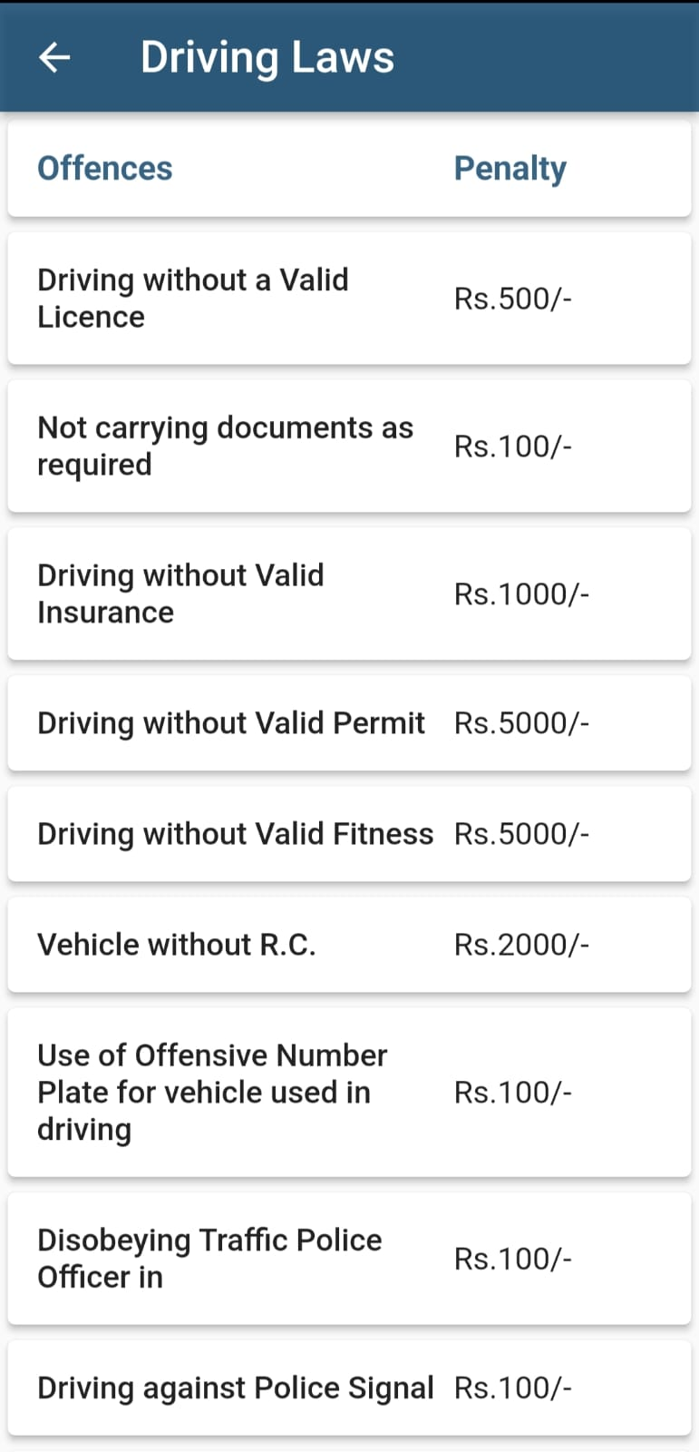

*Figure 3.7‑1* *Screen-7:* Driving Laws

**Purpose:** In this screen show offence and that offence for a penalty for driving laws

Table 3.7‑1 Screen element of Driving Laws

|  |  |  |  |  |  |
| --- | --- | --- | --- | --- | --- |
| **Sr.** | **Screen Element** | **Input Type** | **O/M** | **1/N** | **Description** |
| **1** | Back Arrow | Button |  |  | Back from this page |
| **2** | Offence | Textbox |  |  | Offence side all card in name of offence |
| **3** | Penalty | Textbox |  |  | Penalty side all card in penalty for left side offence |

## Screen-8 Question Bank

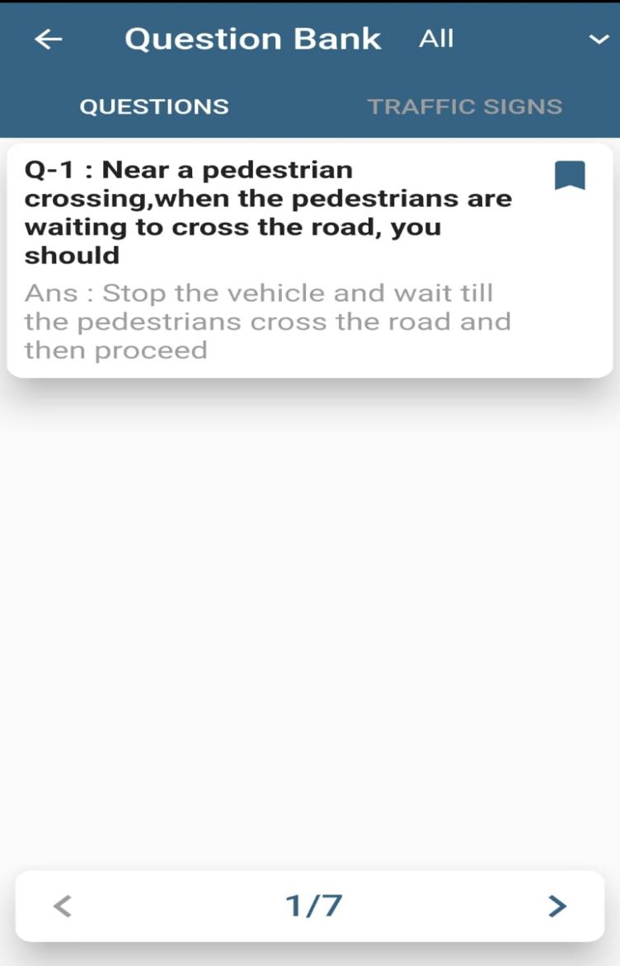

*Figure 3.8‑1* *Screen-8:* Question Bank

**Purpose:** in this screen you read question answer if you want to read only traffic sign read then tick traffic sign read then tick traffic sign and all question is related to traffic sign

Table 3.8‑1 Screen element of Question Bank

|  |  |  |  |  |  |
| --- | --- | --- | --- | --- | --- |
| **Sr.** | **Screen Element** | **Input Type** | **O/M** | **1/N** | **Description** |
| **1** | Back Arrow | Button |  |  | Back from this page |
| **2** | All | Dropdown |  |  | Choose you want to those type question you want to read |
| **3** | Question | Select |  |  | Choose type of question |
| **4** | Card | Textbox |  |  | Read the question answer |
| **5** | Arrow | Button |  |  | Change the question prevuos and next |

# Database Design

## List Of Tables

* **Question**
* **LIcence Process**
* **Driving Law**
* **RTO Office**
* **Statistics**
* **Admin**
* **User**

Table 4.1‑1 Table: Question

|  |  |  |  |  |
| --- | --- | --- | --- | --- |
| **Column** | **Data Type** | **Null** | **Keys & Constrains** | **Default Value & Description** |
| **QuestionID** | int | NN | PK (Auto Increment) |  |
| **Question** | varchar(100) | NN |  |  |
| **Answer** | varchar(100) | NN |  |  |
| **Option_A** | varchar(100) | NN |  |  |
| **Option_B** | varchar(100) | NN |  |  |
| **Option_C** | varchar(100) | NN |  |  |

Table 4.1‑2 Table: Licence Process

|  |  |  |  |  |
| --- | --- | --- | --- | --- |
| **Column** | **Data Type** | **Null** | **Keys & Constrains** | **Default Value & Description** |
| **ProcessID** | int | NN | PK (Auto Increment) |  |
| **ProcessName** | varchar(100) | NN |  |  |
| **ProcessStep** | varchar(500) | NN |  |  |

Table 4.1‑3 Table: Driving Law

|  |  |  |  |  |
| --- | --- | --- | --- | --- |
| **Column** | **Data Type** | **Null** | **Keys & Constrains** | **Default Value & Description** |
| **OffenceID** | int | NN | PK (Auto Increment) |  |
| **Offence** | varchar(100) | NN |  |  |
| **Penalty** | varchat(20) | NN |  |  |
| **Law-No** | varchar(100) | NN |  |  |

Table 4.1‑4 Table: RTO Office

|  |  |  |  |  |
| --- | --- | --- | --- | --- |
| **Column** | **Data Type** | **Null** | **Keys & Constrains** | **Default Value & Description** |
| **StateID** | int | NN | PK (Auto Increment) |  |
| **CityID** | Int | NN |  |  |
| **RTOCode** | varchar(10) | NN |  |  |
| **Address** | Varchar(500) | NN |  |  |
| **Contact** | number(10,0) | AN |  |  |

Ta*b*le 4.1‑5 Statistic

|  |  |  |  |  |
| --- | --- | --- | --- | --- |
| **Column** | **Data Type** | **Null** | **Keys & Constrains** | **Default Value & Description** |
| **StatisticID** | int | NN | PK (Auto Increment) |  |
| **StatisticsName** | varchar(100) | NN |  |  |
| **Data** | varchar(100) | NN |  |  |

Ta*b*le 4.1‑6 Admin

|  |  |  |  |  |
| --- | --- | --- | --- | --- |
| **Column** | **Data Type** | **Null** | **Keys & Constrains** | **Default Value & Description** |
| **AdminID** | int | NN | PK (Auto Increment) |  |
| **AdminName** | varchar(100) | NN |  |  |
| **AdminEmail** | Varchar(50) | NN |  |  |
| **Contact** | Number(10,0) | AN |  |  |
| **Passward** | Varchar(50) | NN |  |  |

Ta*b*le 4.1‑7 User

|  |  |  |  |  |
| --- | --- | --- | --- | --- |
| **Column** | **Data Type** | **Null** | **Keys & Constrains** | **Default Value & Description** |
| **UserID** | int | NN | PK (Auto Increment) |  |
| **UserName** | varchar(100) | NN |  |  |
| **UserEmail** | Varchar(50) | AN |  |  |
| **Contact** | Number(10,0) | AN |  |  |
| **Passward** | Varchar(50) | NN |  |  |

# **Story & Scenario**

## Story-1: Read RTO Office Detail

|  |  |  |
| --- | --- | --- |
| *Story #* ***S1*** | **:** | **As a** user,  **I want to** read RTO office code and other detail,  **So that a** true information for RTU office of particular city. |
| **Priority** | **:** | Medium |
| **Estimate** | **:** | xL |
| **Reason** | **:** | The development of a RTO Detail page is an important and crucial task in the RTO Driving Practice Test System. |

### Scenario# S1.1

|  |  |  |
| --- | --- | --- |
| *Scenario#* ***S1.1*** | **:** | Retrieve RTO Office Code and Details for a City |
| **Prerequisite** | **:** | Internet connection required |
| **Acceptance Criteria** | **:** | **Given:** the user wants to find information about an RTO office.  **When:** the user provides the name of a city, "City Name".  **Then:** the system should look up the RTO office details for "City Name"  And the system should provide the following information:  | RTO Office Code | RTO Office Name | City | State |  | ABC-123 | Sample RTO Office 1 | CityName | StateName |  | XYZ-789 | Sample RTO Office 2 | AnotherCity | AnotherState |  And the system should display a message indicating the search was successful |

### Scenario# S1.2

|  |  |  |
| --- | --- | --- |
| *Scenario#* ***S1.2*** | **:** | Search for RTO Office Information with Invalid City |
| **Prerequisite** | **:** | Internet connection required |
| **Acceptance Criteria** | **:** | **Given:**the user wants to find information about an RTO office.  **When:** the user provides an invalid city name, "InvalidCity".  **Then** the system should notify the user that the city "InvalidCity" is not found  And the system should not display any RTO office details. |

### Scenario# S1.3

|  |  |  |
| --- | --- | --- |
| *Scenario#* ***S1.3*** | **:** | Retrieve Multiple RTO Offices for a City. |
| **Prerequisite** | **:** | Internet connection required |
| **Acceptance Criteria** | **:** | **Given**: the user wants to find information about RTO offices in a city And the user provides the name of a city, "CityName".  **When**:the system looks up the RTO offices in "CityName"  **Then** : the system should provide a list of RTO offices in "CityName"  And the system should display the following RTO office information:  | RTO Office Code | RTO Office Name | CityName |  | ABC-123 | Sample RTO Office 1 | CityName |  | XYZ-789 | Another Sample RTO Office | CityName |  | DEF-456 | Yet Another RTO Office | CityName |  And the system should indicate the total number of RTO offices found: 3 |

## Story-2: Demo Exam

|  |  |  |
| --- | --- | --- |
| *Story #* ***S2*** | : | **As a** user,  **I want to** give exam to like a RTO test exam  **So that** I Want all thing is like a real exam. |
| **Priority** | **:** | High |
| **Estimate** | **:** | XXL |
| **Reason** | **:** | Development of the Exam page is an important and main part of this project.In this page developer should all things to take test |

### Scenario# S2.1

|  |  |  |
| --- | --- | --- |
| *Scenario#* ***S2.1*** | **:** | Start and Complete an RTO Test Exam |
| **Prerequisite** | **:** | Internet connection required |
| **Acceptance Criteria** | **:** | **Given:** the user wants to take an RTO test exam  **When:** the user begins the exam  **Then** the system should present the first exam question And the user should select an answer to the question When the user submits the answer Then the system should present the next exam question And this process should continue until all questions are answered When the user answers the last question and submits it Then the system should end the exam And the user should receive a score and feedback And the system should provide an option to review the exam results |

### Scenario# S2.2

|  |  |  |
| --- | --- | --- |
| *Scenario#* ***S2.2*** | **:** | Review Exam Results |
| **Prerequisite** | **:** | Internet connection required |
| **Acceptance Criteria** | **:** | **Given:** the user has completed an RTO test exam And the user wants to review the exam results.  **When:** the user selects the option to review the exam results.  **Then** the system should display a summary of the exam And the user should see their score and pass/fail status And the user should be able to review each question and their answers And the user should see correct answers for each question And the system should provide feedback on incorrect answers |

### Scenario# S2.3

|  |  |  |
| --- | --- | --- |
| *Scenario#* ***S2.3*** | **:** | Take an RTO Test Exam with a Time Limit |
| **Prerequisite** | **:** | Internet connection required |
| **Acceptance Criteria** | **:** | **Given**:the user wants to take an RTO test exam And the user has a limited time of 60 minutes for the exam  **When**: the user begins the exam.  **Then** :the system should start a timer for 30 minutes And the user should be presented with the first exam question And the user should be able to answer questions within the time limit When 60 minutes elapse Then the system should automatically end the exam And the user should receive a message indicating the time limit has been reached And the user should see their score and feedback based on answered questions |

## Story-3: Select State and Language

|  |  |  |
| --- | --- | --- |
| *Story #* ***S3*** | **:** | **As a** user,  **I want** to change my state or language,  **So that** I want read only those particular state question and test |
| **Priority** | **:** | High |
| **Estimate** | **:** | L |
| **Reason** | **:** | State selection page is also need for user because all state having different question so this page is more required and take care about calling API. |

### Scenario# S3.1

|  |  |  |
| --- | --- | --- |
| *Scenario#* ***S3.1*** | **:** | Change State and Language Preferences |
| **Prerequisite** | **:** | Internet connection required |
| **Acceptance Criteria** | **:** | **Given:** the user wants to access questions and tests specific to a particular state.  **When:** the user accesses their account settings And the user selects a new state preference, "NewState" And the user selects a new language preference, "NewLanguage".  **Then** the system should update the user's preferences to "NewState" and "NewLanguage" And the user should see a confirmation message of the preferences update. |

### Scenario# S3.2

|  |  |  |
| --- | --- | --- |
| *Scenario#* ***S3.2*** | **:** | Access Questions and Tests for the Selected State |
| **Prerequisite** | **:** | Internet connection required |
| **Acceptance Criteria** | **:** | **Given:** the user has changed their state preference to "NewState" And the user has changed their language preference to "NewLanguage".  **When:** the user navigates to the questions and tests section.  **Then** the system should display questions and tests specific to "NewState" And the content should be in "NewLanguage" And the user can start accessing and answering questions for "NewState" |

### Scenario# S3.3

|  |  |  |
| --- | --- | --- |
| *Scenario#* ***S3.3*** | **:** | Change State Preference |
| **Prerequisite** | **:** | Internet connection required |
| **Acceptance Criteria** | **:** | **Given**: the user wants to access questions and tests specific to a different state.  **When**: the user accesses their account settings And the user selects a new state preference, "Texas".  **Then** :the system should update the user's state preference to "Texas" And the user should see a confirmation message of the state preference update. |

## Story-4: Add Question

|  |  |  |
| --- | --- | --- |
| *Story #* ***S4*** | **:** | **As a** admin,  **I want** to add or edit question in API ,  **So that** I need one type of format for add or edit question. |
| **Priority** | **:** | HIgh |
| **Estimate** | **:** | XL |
| **Reason** | **:** | This page is important and take care about which API database table affect to new changes. |

## Story-5: Statistics

|  |  |  |
| --- | --- | --- |
| *Story #* ***S5*** | **:** | **As a** user,  **I want** to show all the number of vehicle , Road Accidents,Driving License,  **So that** I need number of all figure. |
| **Priority** | **:** | Low |
| **Estimate** | **:** | XS |
| **Reason** | **:** | Statistics is not important for this project and number of figure for all is a information base that not more Affiance. |

## Story-6: License Procedure

|  |  |  |
| --- | --- | --- |
| *Story #* ***S6*** | **:** | **As a** user,  **I want** to show step of the applying for the Licence ,  **So that** All Procedure having a all step from the beginning. |
| **Priority** | **:** | Low |
| **Estimate** | **:** | S |
| **Reason** | **:** | License Procedure is not important for this project and all step is a procedure |

## Story-7: Driving Laws

|  |  |  |
| --- | --- | --- |
| *Story #* ***S7*** | **:** | **As a** user,  **I want** to show all laws of Driving,  **So that** I required all Laws and those laws penalty I found easily in page. |
| **Priority** | **:** | Medium |
| **Estimate** | **:** | S |
| **Reason** | **:** | Because this page is like theory base page in this page not any sensitive information. |

## Story-8: Question Bank

|  |  |  |
| --- | --- | --- |
| *Story #* ***S8*** | **:** | **As a** user,  **I want** to read all the question for the preparing examination,  **So that** I need question and answer in one page. |
| **Priority** | **:** | High |
| **Estimate** | **:** | M |
| **Reason** | **:** | This Page is most Required for the application because its main part of this project. |

## Story-9: Practice Test

|  |  |  |
| --- | --- | --- |
| *Story #* ***S9*** | **:** | **As a** user,  **I want** practice for the question bank question,  **So that** I need all question having three option and when I choose the show me selected option is correct or not. |
| **Priority** | **:** | High |
| **Estimate** | **:** | M |
| **Reason** | **:** | This Page is most Required for the application because its main part of this project. |

## Story-10: FAQ

|  |  |  |
| --- | --- | --- |
| *Story #* ***S10*** | **:** | **As a** user,  **I want** to about more information for vehical ,  **So that** I need all rule and why those required for driving . |
| **Priority** | **:** | Low |
| **Estimate** | **:** | S |
| **Reason** | **:** | This is not much important for the application. |

# Test Cases